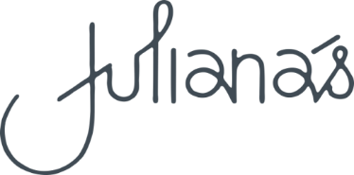

Small Plates

Garlic Bread  Turkish loaf toasted with garlic, butter and parsley GFA | 8
Garlic Prawns  with toasted Turkish loaf GFA | 19
Walnut Crumbed Baked Brie  with apricot vanilla relish and crostini V | 19
Chicken Bites  buttermilk thigh, crisp coated with chilli honey and ranch dip | 19
Caesar Salad  baby cos lettuce, homemade croutons, shaved parmesan,  grilled bacon and Caesar dressing GFA | 19
Calamari  with chili ginger and scallion squid ink aioli | 19
Italian Meatballs  veal, pork, beef, tomato sauce and fresh mozzarella | 19
Roast Cauliflower and Haloumi  with crispy chickpeas, charred corn and hummus GF/V | 19
.

Please inform your waiting staff of any special dietary requirements

Please note 15% surcharge will apply on public holidays

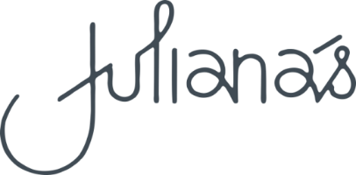

Mains

Caesar Salad  baby cos lettuce, homemade croutons, shaved parmesan,  grilled bacon and Caesar dressing GFA  Add Chicken  Crispy Chili Ginger Tofu  with Szechuan green beans, sweet soy glaze and steamed rice V | 26  36  28
Beer Battered Fish and Chips  with slaw, tartare sauce and lemon  Crispy Skin Salmon  with soba noodle salad and sticky soy dressing  Tandoori Chicken  with coriander chutney and basmati rice GF  Lamb Shank  red wine braised lamb, with wilted greens,  baby onions and potato puree | 38  44  38  44
St Louis Pork Ribs  with slaw, potato puree and apple cider BBQ sauce | 38
Angus Beef Rib Eye  chargrilled served with garlic butter,  red wine jus, fries and green salad GF | 47
500g T Bone Steak  chargrilled served with garlic butter,  red wine jus, fries and green salad GF | 59

Sides

Bowl of fries | 9
Fries tossed in truffle oil topped with parmesan | 12
Potato of the day | 9
Seasonal vegetables | 9
Seasonal green salad | 9
Fried free range eggs (x2) | 9

Desserts |  | Liqueur Coffee
Sticky Toffee Pudding  butterscotch sauce and ice cream GFA | 18 | Irish Coffee  Whisky, coffee and cream | 18
Apple Strudel  custard and cream | 18 | Irish Cream Coffee  Baileys, coffee and cream | 18
Banoffee Pie  vanilla bean ice cream | 18 | French Coffee  Cognac, coffee and cream | 18
Affogato  vanilla bean ice cream  with a shot of espresso  and your choice of liqueur GF | 18 | Italian Coffee  Amaretto, coffee and cream  Calypso Coffee  Kahlua, coffee and cream | 18  18
Hot Fudge Honeycomb Sundae | 18
White Chocolate Raspberry Sundae | 18 | To Finish
Cheese Selection  blue cheese, cheddar, brie and accompaniments with crackers  19 for 1 |  | Limoncello (Italy)  Sileni Grand Reserve Late Harvest | 10  12
29 for 2  $6 for each additional cheese |  | Port – Tawny or Ruby | 12

Please note 15% surcharge will apply on public holidays.

