Day Menu 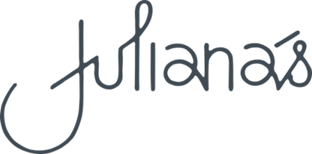

Served daily from 10am to 6pm

**Chips *$9***

*with tomato sauce and aioli*

***Garlic bread $8 / for two $15***

*for one or two people*

**Soup of the day GFA/V $16** *served with garlic bread*

**Toasted sandwiches *$16***

*four halves with a choice of three fillings*

*cheese/tomato/onion/ham /pineapple/ sweetcorn*

**Taco bowl V, DFA, GFA $19**

*crispy tortilla bowl filled with mixed chilli beans, jalapeno and greens*

*topped with shredded cheese served with sour cream and salsa*

**Classic burger $24**

*with your choice of beef or chicken on toasted brioche bun*

*served with**grilled cheese/tomato/lettuce/onion rings/gherkins/relish and fries*

Extras $3 bacon/egg/mushroom

**Beer battered fish and chips *$28***

*served with salad**and tartare sauce*

***Please note 15% surcharge will apply on public holidays***